RETEK ASSORT SCREENS

Login
The ASSORT system will appear as an icon on the user’s Windows desktop. Upon opening the application the user will be asked to log on using a designated user id and password.

Sample Screen
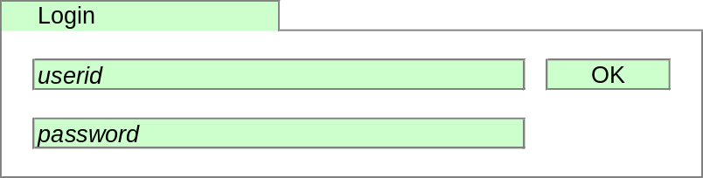

Workbook Types
ASSORT is organised as a number of workbooks, each designed to achieve a particular purpose.
- The Ranging Workbook is used to perform range changes.
- The Dummy New Lines Workbook is used to set-up and maintain Dummy New Lines and to link Dummy New Lines to CW products.
- The Sales History Workbook is used to select the required History Period to be used for the performance data in the Ranging Workbook.
- The Live & Authorised Ranges Workbook is used to view the current live range for any Merchandising Group. In addition the workbook can be used to view any authorised ranges not yet live (i.e. a range has been authorised but has not yet reached its effective date).

Ranging Workbook

The Ranging workbook is organised as a number of tabs, which are designed to lead the Commercial user through the ranging process.
- The Buddy Forecast Tab contains one window, which is used for selecting a product whose performance data is to be used in forecasting sales for another product.
- The Cluster Ranging Tab contains three windows:
- The All Range Classes Window, which is used to make core range changes for each Store Cluster and Range Class using a product centric viewpoint (i.e. shows how a product is ranged across all Range Classes).
- The Individual Range Class Window, which is used to make core range changes for each Store Cluster and Range Class using a Range Class centric viewpoint (i.e. shows how products are ranged within a specific Range Class).
- The Store Count Window, which shows information about the number of stores allocated to each Range Class within a Store Cluster. This window is linked to the ranging windows so that it always shows information for the Store Cluster currently being ranged.
- The Overlay Ranging Tab contains two windows:
- The Overlay Ranging Window, which is used to specify products to overlay the Cluster range for each Store Cluster and Range Class.
- The Overlay Store Count Window shows the number of stores in Range Class within each Store Cluster for each overlay type.
- The Validation Tab contains two windows:
- The Validation Summary Window, which shows the number of errors in each Store Cluster.
- The Validation Detail Window, which shows details of any errors or warnings identified when the system checks the ranges.
- The Summary Tab contains three windows:
- The Summary Window, which shows the highest and lowest Range Class for each product in each Store Cluster, both As Is and To Be, and the number of stores the product will be ranged in
- The Range Count & Participation Window, which shows the number of products in the range for each Store Cluster, both As Is and To Be, the number of deleted products, the number of changes made and the number of lines used as Overlays
- The Overlay Usage Window, which shows a list of Overlay lines and their victim lines for each Store Cluster.
- The Send / Submission Tab contains two windows:
- The Send Working Range Window, which can be used to send ranges that are still under construction to Merchandising
- The Submit Final Range Window, which is used to submit the final ranges to Merchandising.
- The Range Properties Tab contains two windows:
- The Range Properties Window, which shows general information about the ranges in the ranging workbook, such as the type of range change, e.g. Refresh, the effective dates for the range changes and the Sales History period used.
- The Range Class Matrix Window, which shows store count by Range Class within each Store Cluster and a total for all Store Clusters.

Workbook Build Wizard

Process Flow
The workbook build wizard will guide the user through the following process

Sample Screens
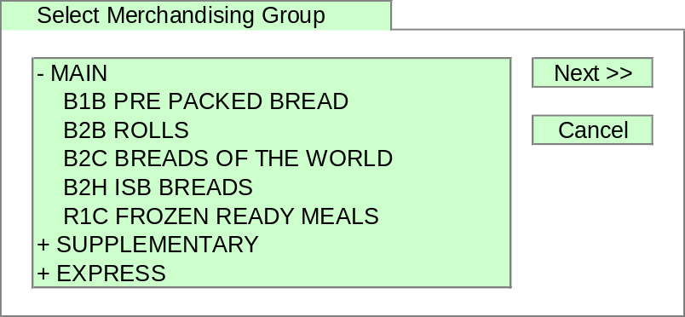

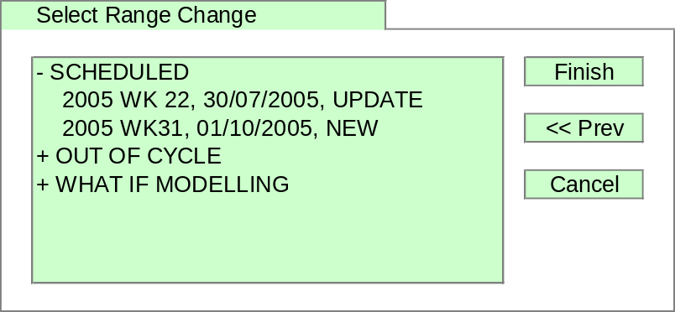

Cluster Ranging Tab

All Range Classes Window
The All Range Classes Window is which is used to make core range changes for each Store Cluster and Range Class using a product centric viewpoint (i.e. shows how a product is ranged across all Range Classes).

Store Count Window
The Store Count Window shows a number of pieces of information about each Range Class within the Store Cluster currently being ranged. A user will use this window to obtain information about the number of Stores across the Range Classes within each Store Cluster to assist in making ranging decisions. The window is positioned permanently below the ranging window and shows information about the cluster currently being ranged.

Sample Screen

Default Screen
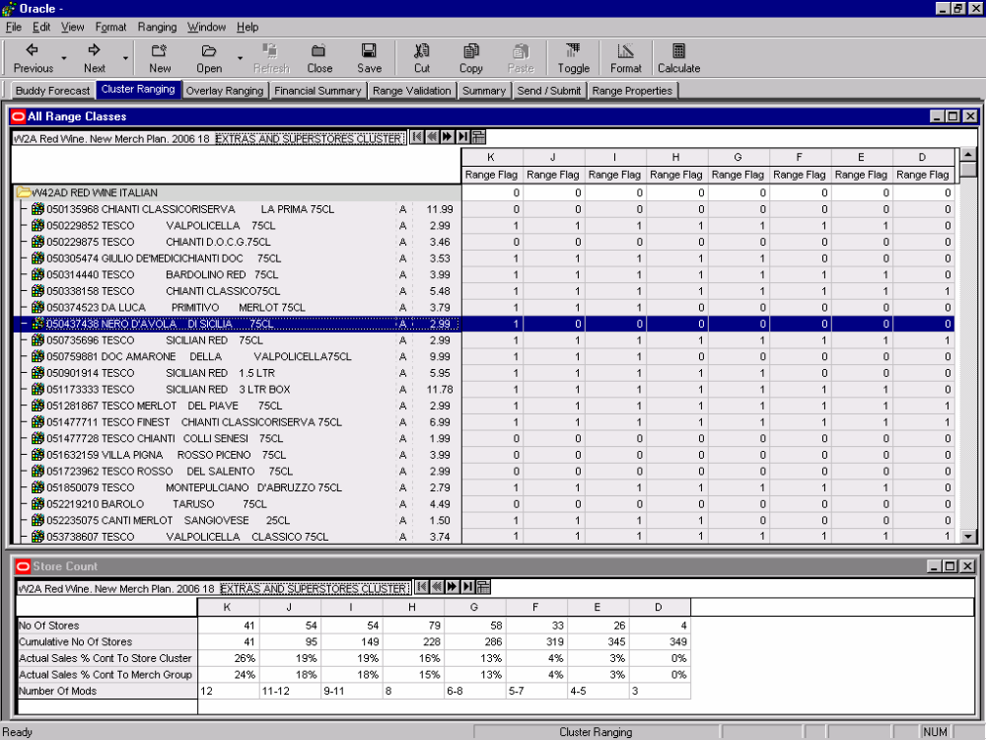

Individual Range Class Window
The Individual Range Class Window can be used for two purposes.
First the window can be used to make core range changes for each Store Cluster and Range Class using a Range Class centric viewpoint (i.e. shows how products are ranged within a specific Range Class).
Second Range Class can be turned off to give a Store Cluster view of the range including highest and lowest Range Class, Sales History and Sales ‘To Be’ for each product.

Sample Screen

Default Screen
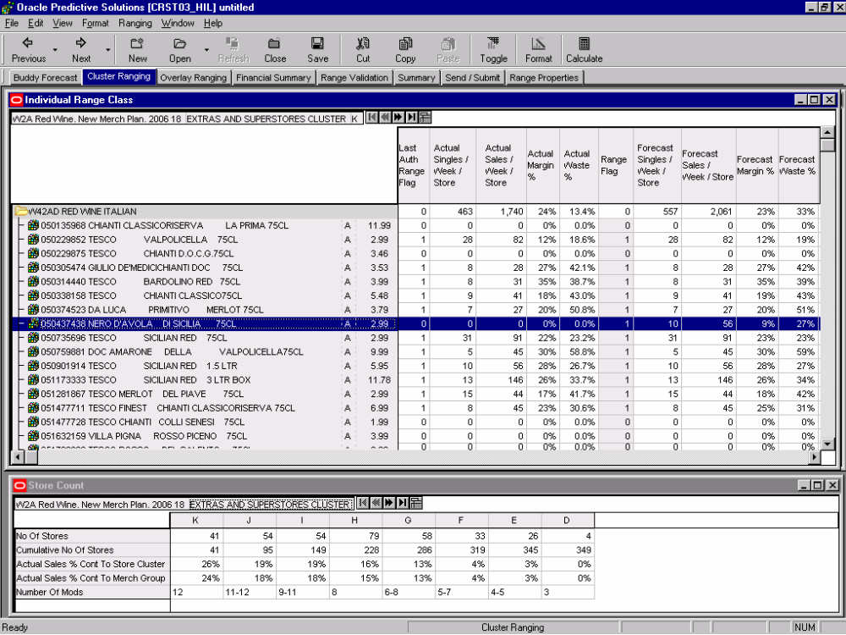

Overlay Ranging Tab

Overlay Ranging Window
The Overlay Ranging Window is used to specify products to be overlaid on the core range for each Store Cluster for each Overlay Type specified in Pre-Ranging.

Sample Screen
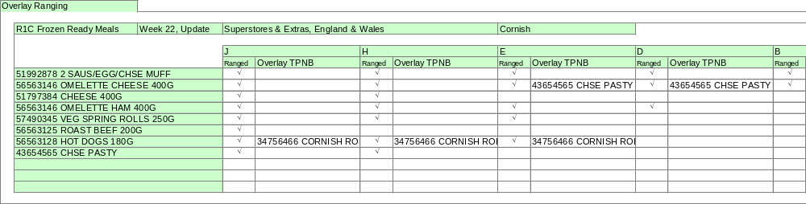

Overlay Store Count Window
The Overlay Store Count Window shows the number of stores for each Range Class within the Store Cluster currently being ranged for each overlay type. The window is positioned permanently below the ranging window and shows information about the cluster currently being ranged. (This is a deliverable for February.)

Sample Screen
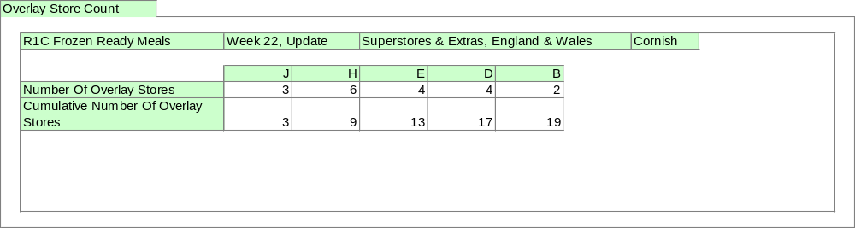

Range Validation Tab

Validation Summary Window
The Validation Summary Window shows the numbers of errors or warnings for the range for each Store Cluster.

Validation Detail Window
The Validation Detail Window shows any errors in the range or any warnings for the range. Only products that have errors will be displayed. The user will use this screen to ensure the range has no errors that will stop submission to Merchandising. In addition there may be warnings about a range that will not stop a range being submitted but about which the user should be aware.

Sample Screen
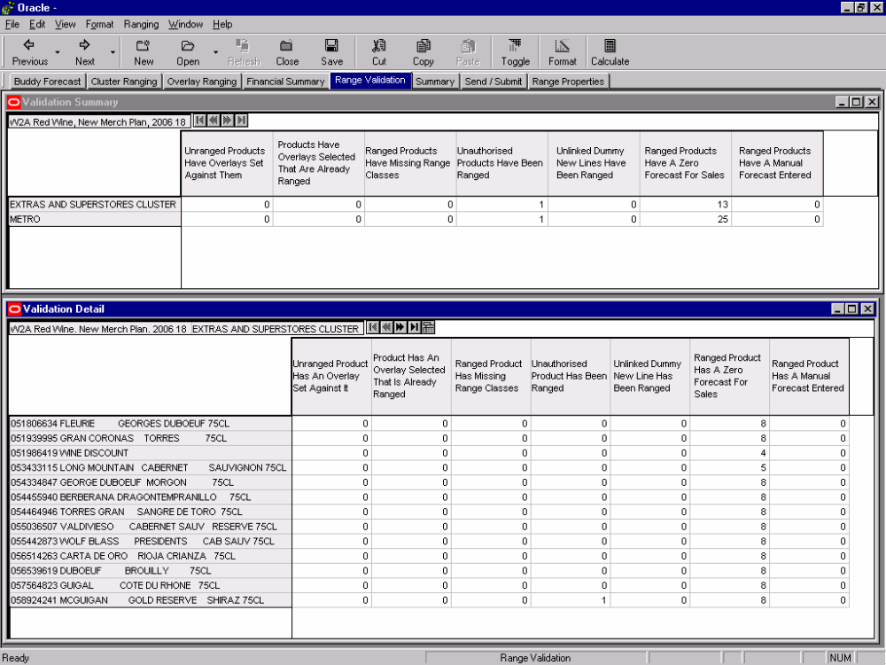

Summary Tab

Summary Window
The Summary Window displays information about the range classes and number of stores for each product across its Store Clusters.

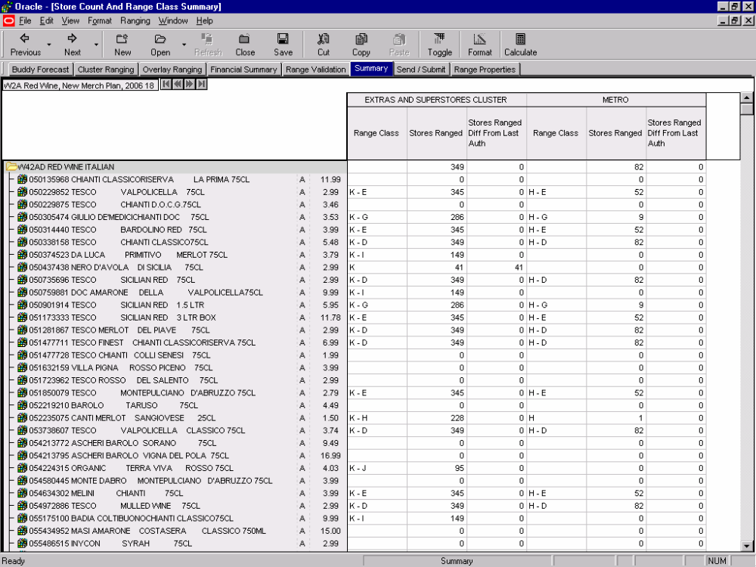
Sample Screen

Send/Submission Tab

Send Working Range Window
The Send Working Ranges Window is used to send ranges to Merchandising so that a range can be modelled in Pro-Space at an early stage in the range change cycle, for example before visiting the Merchandising Centre. Typically this will be used only for major range updates and usually only for the largest Range Class.
Sending a range does not indicate that the range has been completed in any way, it is still considered to be work in progress. The Submit Final Range Window is used to send the completed range from ASSORT to Merchandising.

Submit Final Range Window
The Submit Final Range Window is used to send the completed range from ASSORT to Merchandising for each Store Cluster. When a Store Cluster is submitted it is locked within ASSORT to prevent any further changes.
In addition the window can be used to unlock Store Clusters previously submitted to Merchandising and as a result locked in ASSORT. This is to support the re-planning of a Store Cluster rejected by Merchandising.

Sample Screen
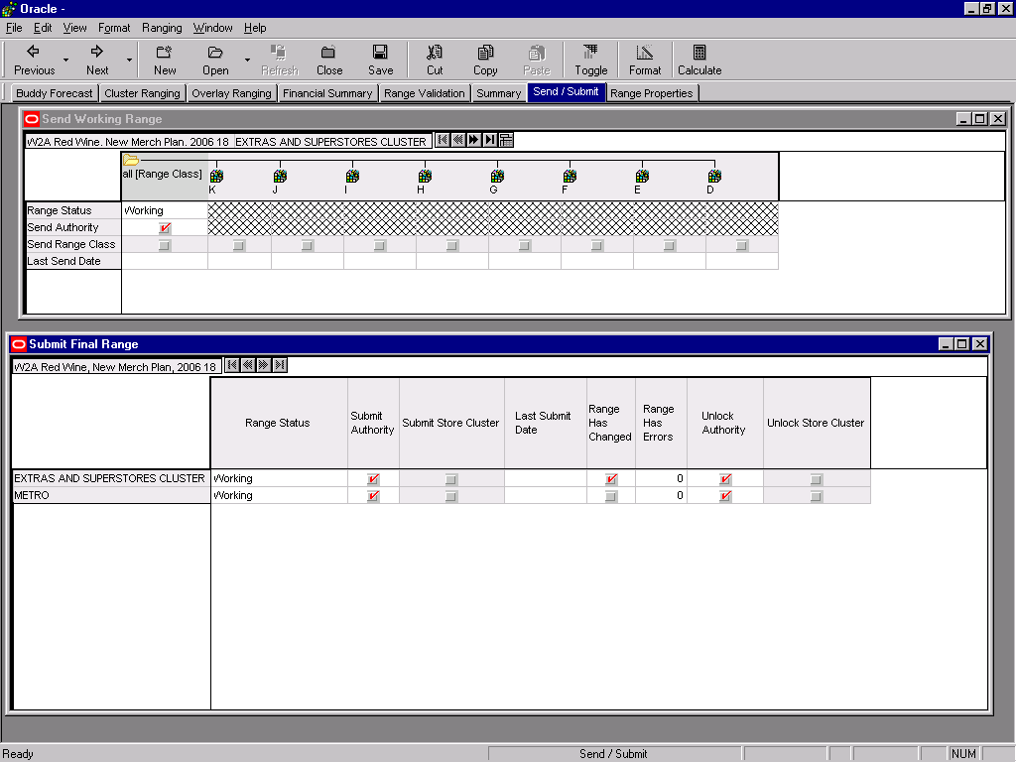

Range Properties Tab

Range Properties Window
The Range Properties Window shows general information about the Range Change.

Range Class Matrix Window
The Range Class Matrix Window shows the store count by Store Cluster and Range Class. A user will use this window to obtain information about the number of Stores across all Range Classes and Store Clusters within the Range Change.

Sample Screen
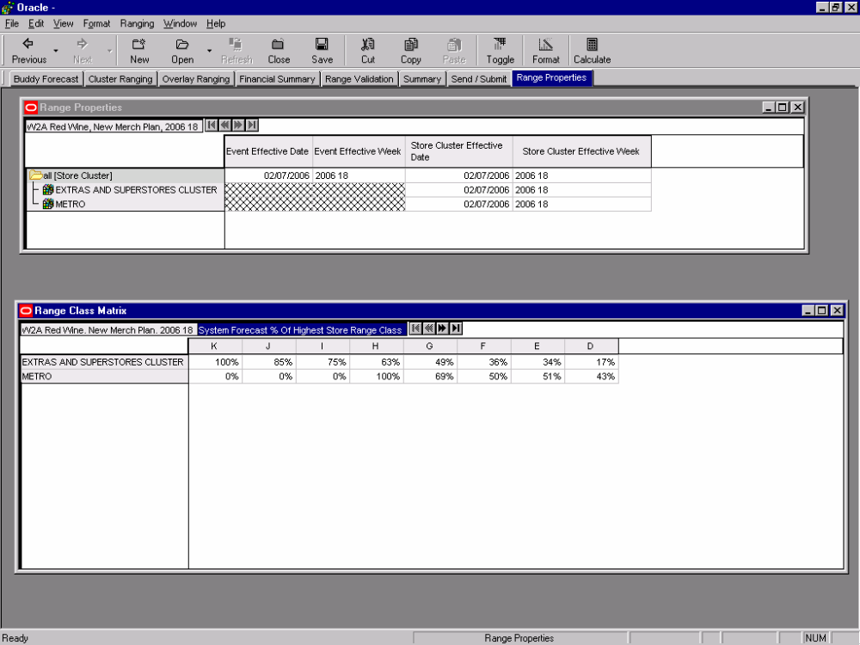

Dummy New Lines Workbook

The Dummy New Lines Workbook is organised as a number of tabs, which are designed to lead the Commercial user through the Dummy New Lines process.
- The Dummy New Lines Set-Up Tab contains one window:
- The Dummy New Lines Set-Up Window is used to enter descriptions for each Dummy New Line to be used in ranging.
- The Dummy New Lines Linking Tab contains one window:
- The Dummy New Lines Linking Window is used to link Dummy New Lines to products from CW.
- The Parameters Tab contains one window:
- The Parameters Window is used to set the number of unused Dummy New Lines to be available for each Sub Group

Workbook Build Wizard

Process Flow
The workbook build wizard will guide the user through the following process


Sample Screen
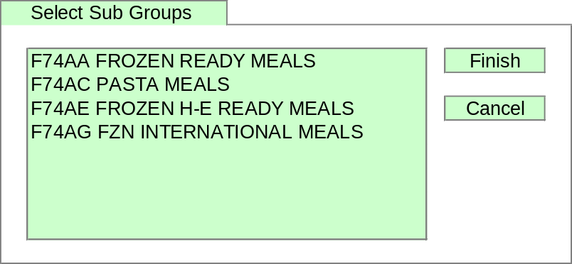

Dummy New Lines Set-Up Window
The Dummy New Lines Set-Up Window is used to enter descriptions for any Dummy New Lines to be used in ranging.

Sample Screen
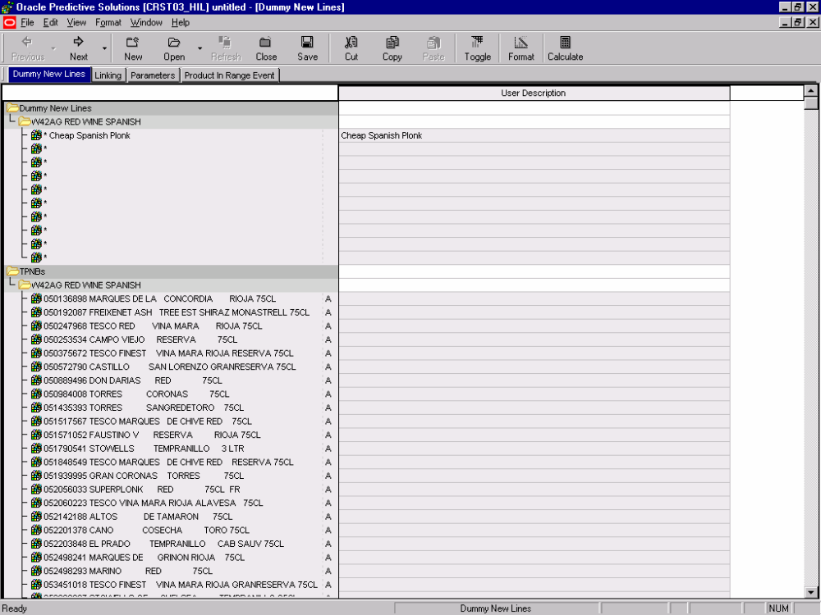

Dummy New Lines Linking Window
The Dummy New Lines Linking Window is used to link Dummy New Lines to products in CW.

Sample Screen
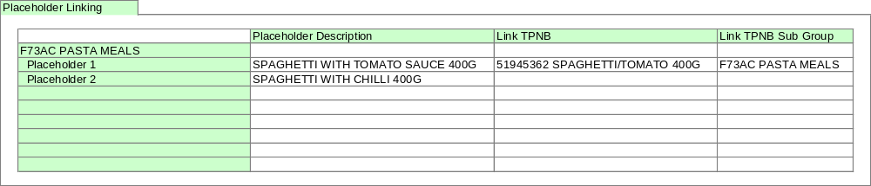

Parameters Window
The Parameters Window is used to override the number of unused Dummy New Lines per Sub Group. The default for each Sub Group will be 50.

Sample Screen
